**Final Case Study 1**

1. S3 bucket creation:

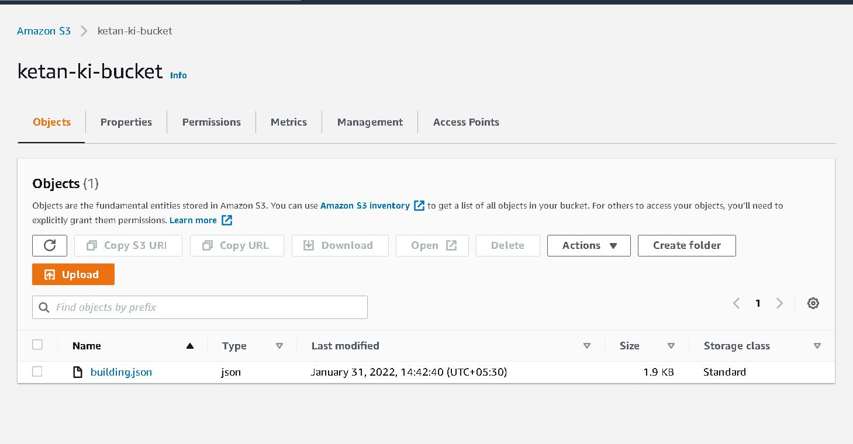

2. JSON Crawler 1:

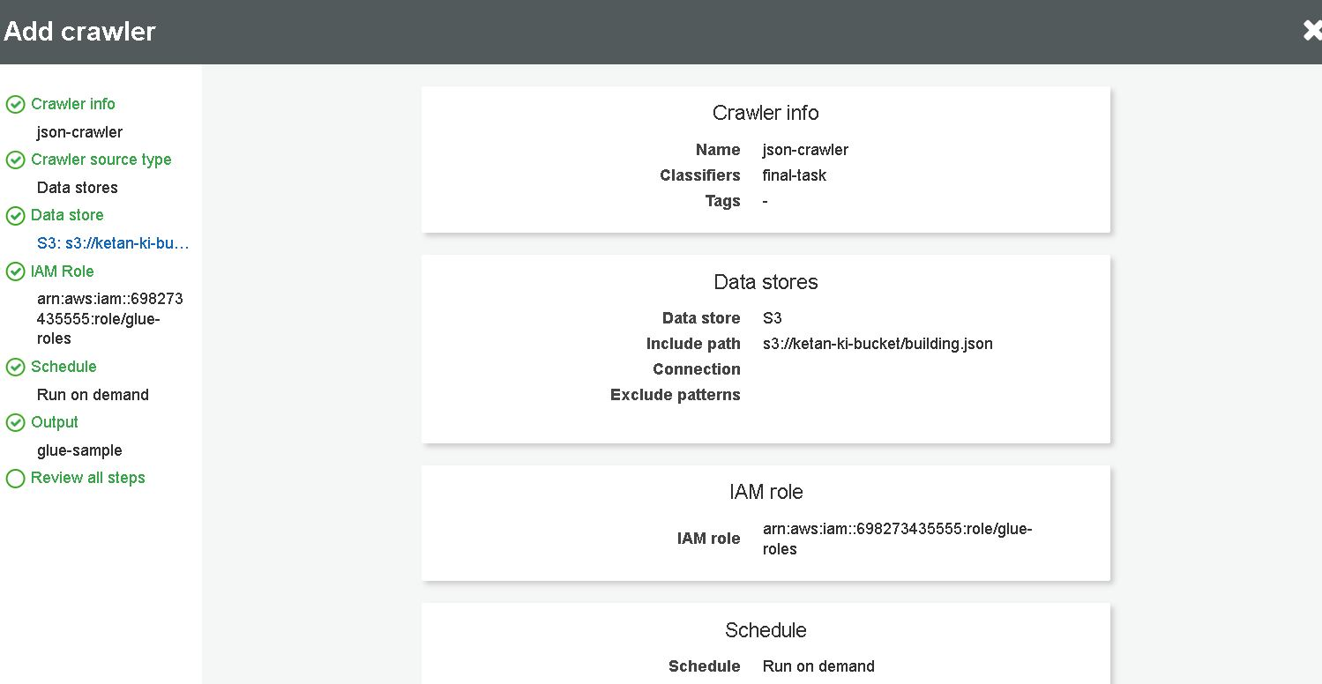

3. JSON Crawler 2:

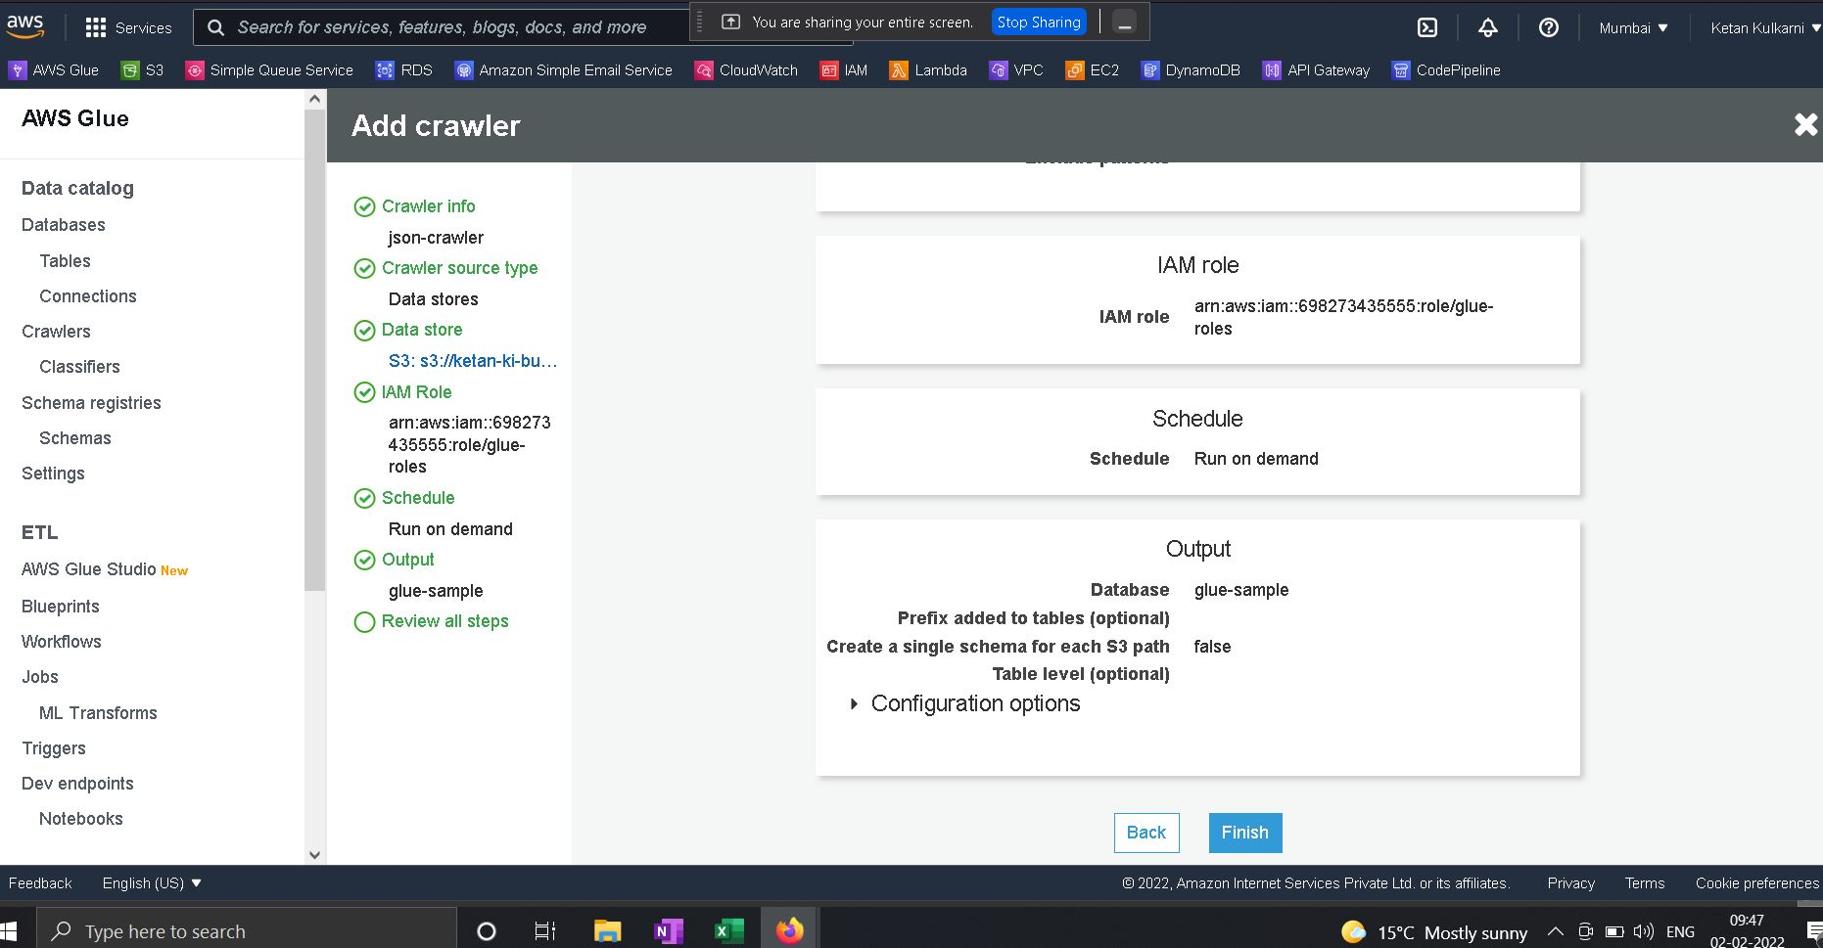

4. Glue Role Creations:

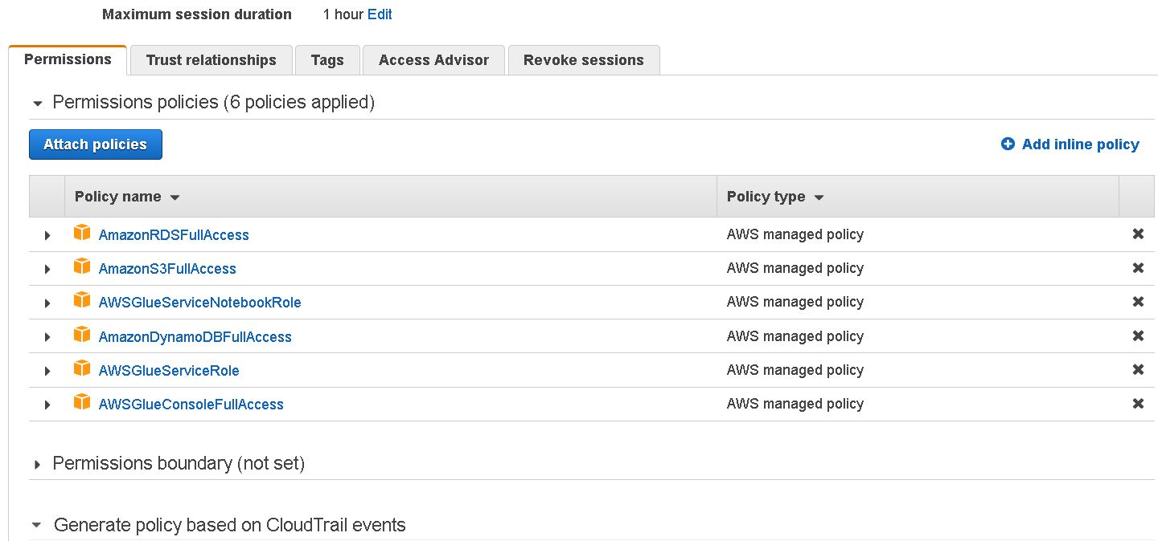

5. JSON Table Structure:

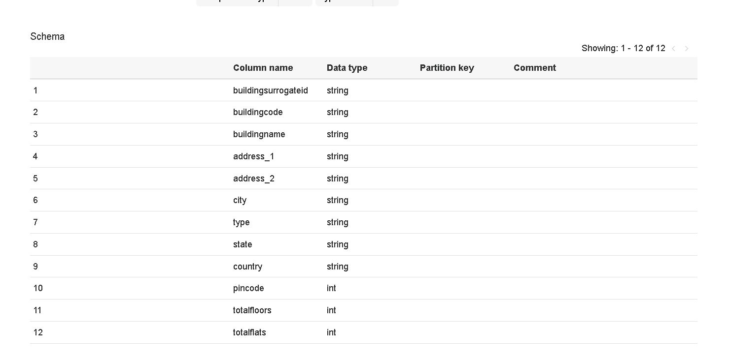

6. JSON Job Created:

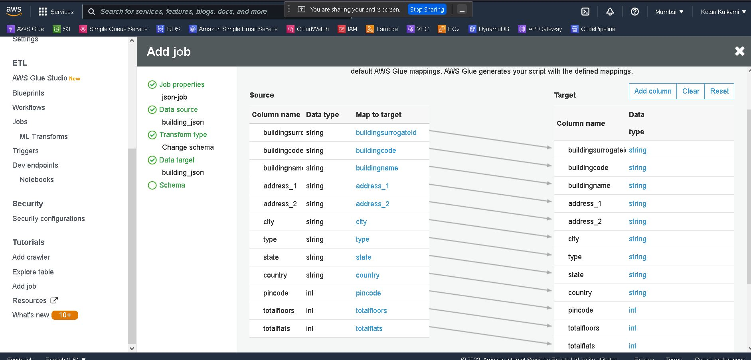

7. Outbound Rules Added:

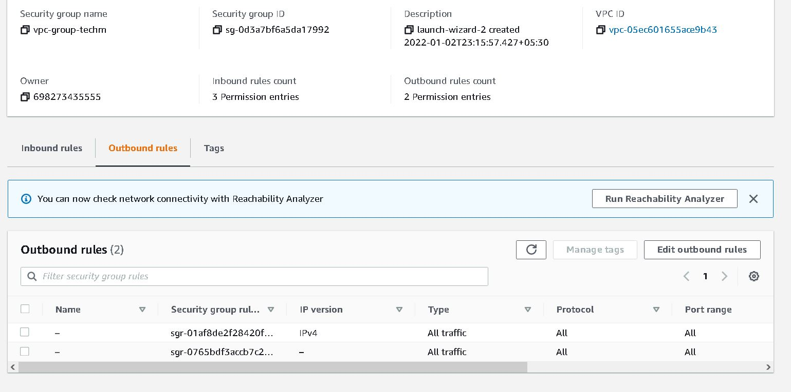

8. Inbound Rules Created:

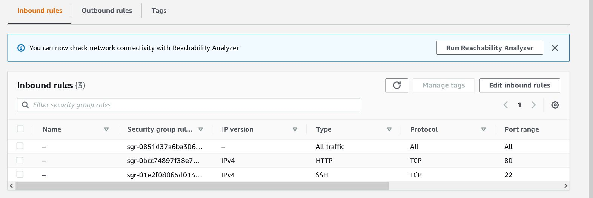

9. RDS Service:

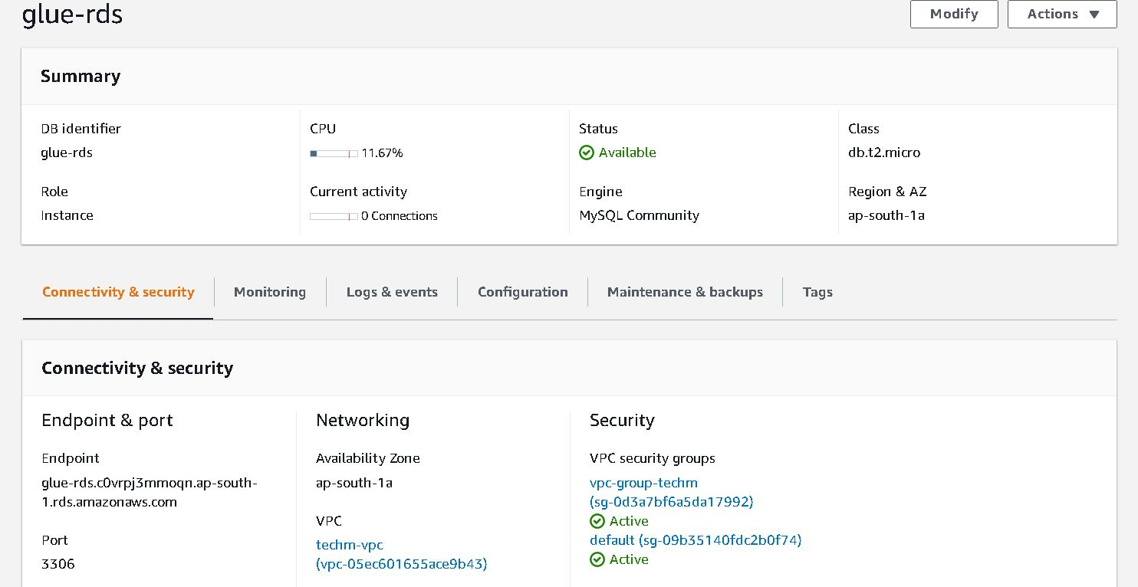

10. Glue-RDS Connectivity:

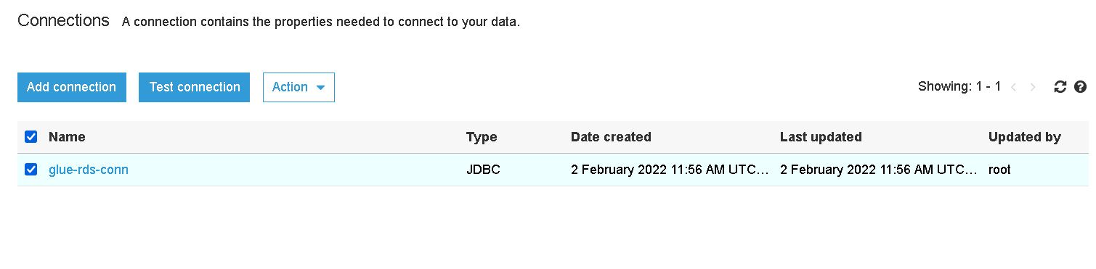

11. RDS Endpoint:

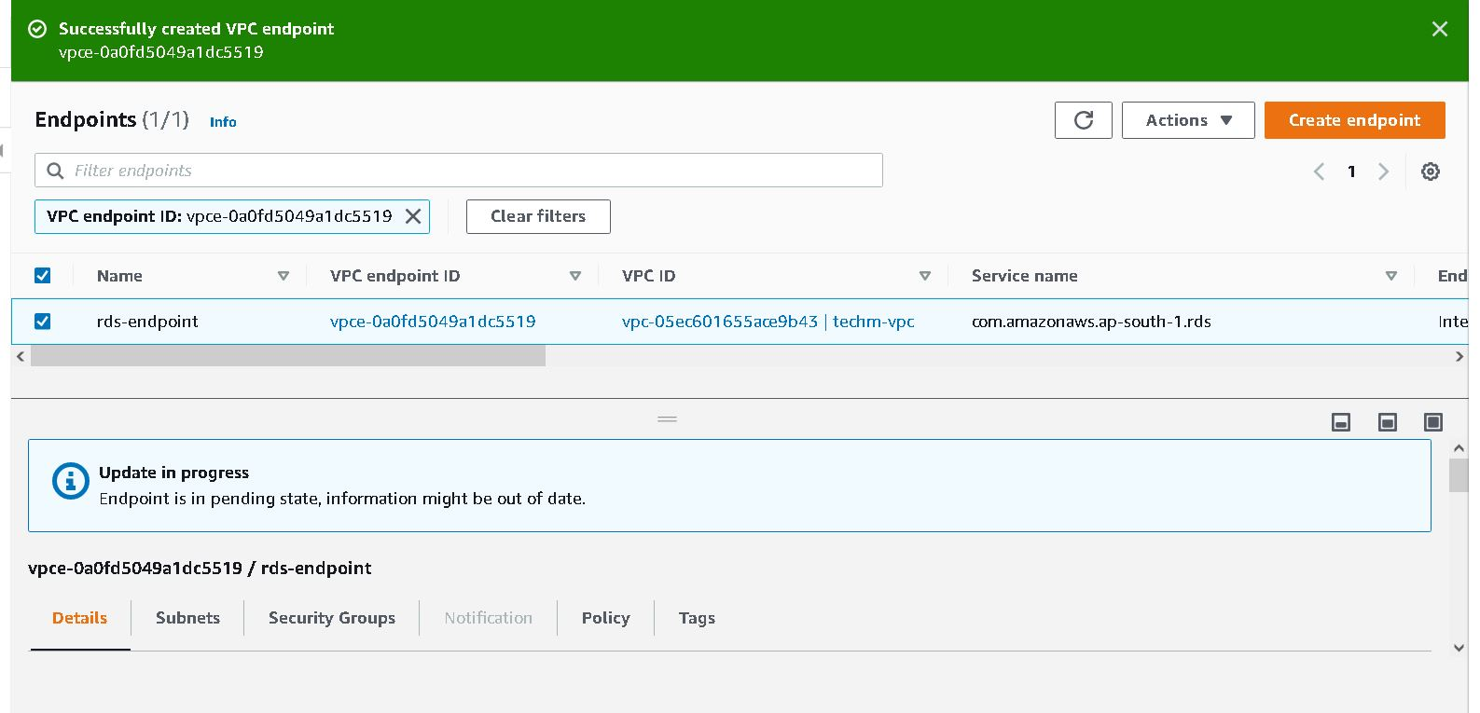

12. VPC Endpoint:

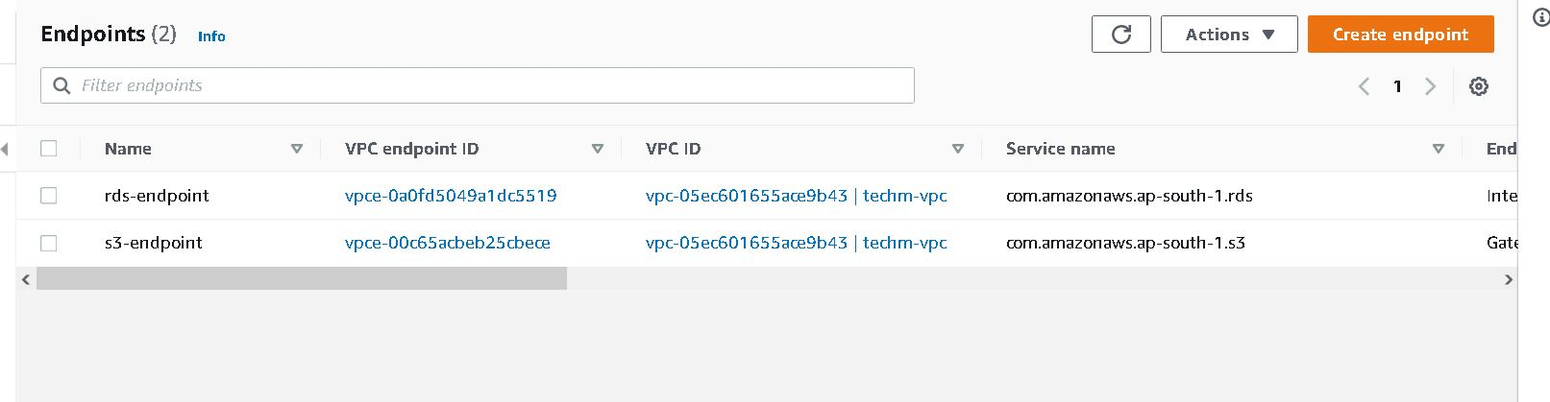

13. S3 Crawler:

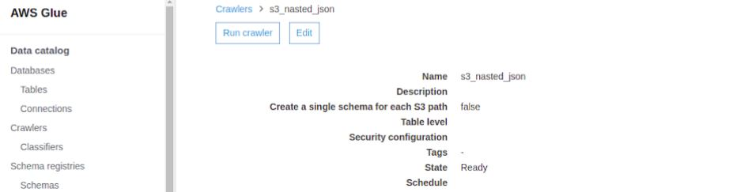

14. Building Schema Details:

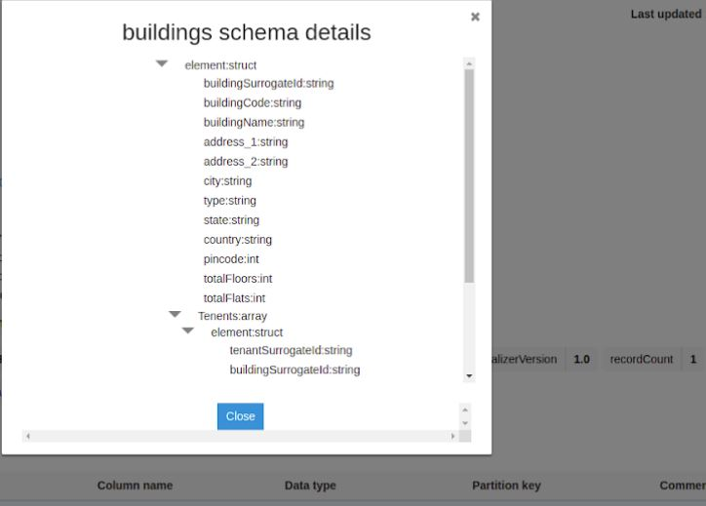

15. Details of Endpoint for Development:

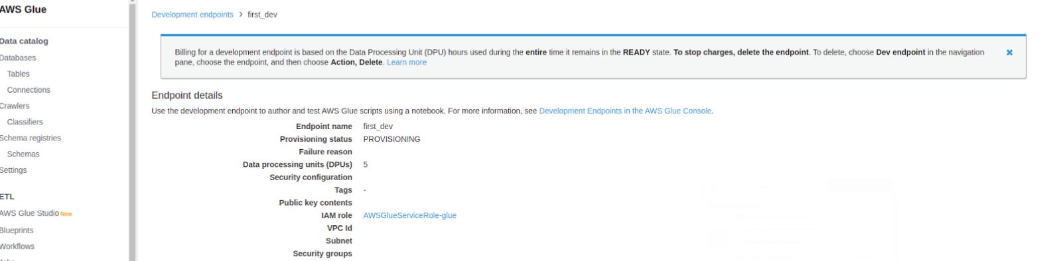

16. DynamoDB Table Structure:

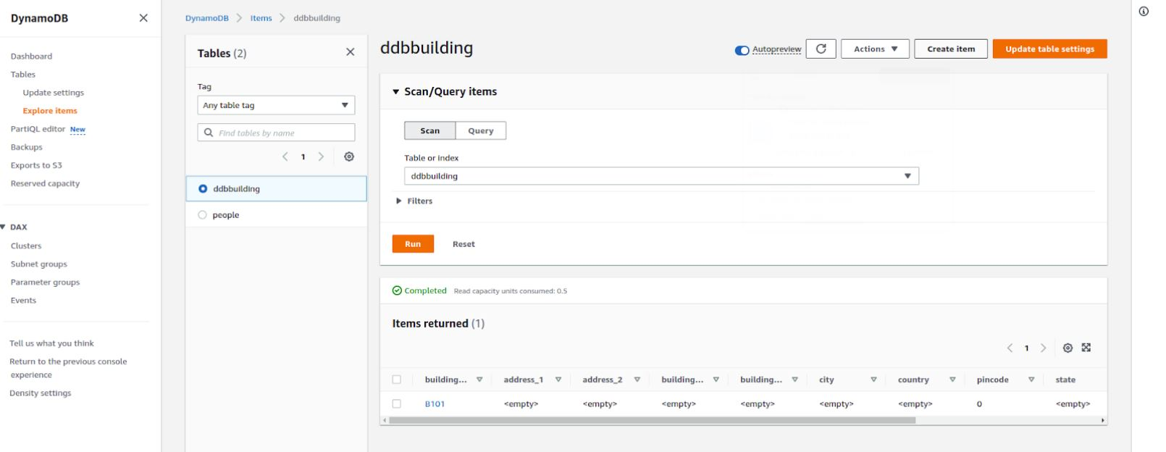

17. Crawler for DynamoDB table:

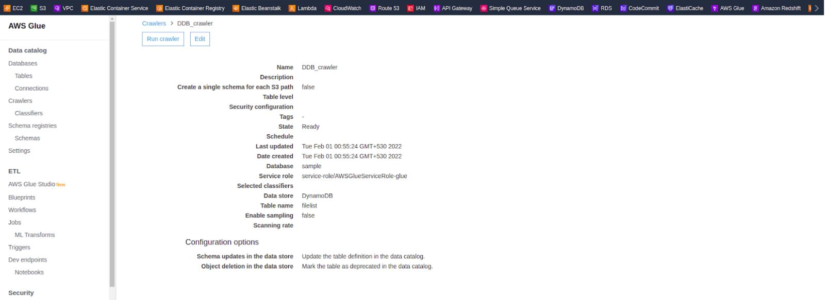

18. AWS Glue Notebook Creation:

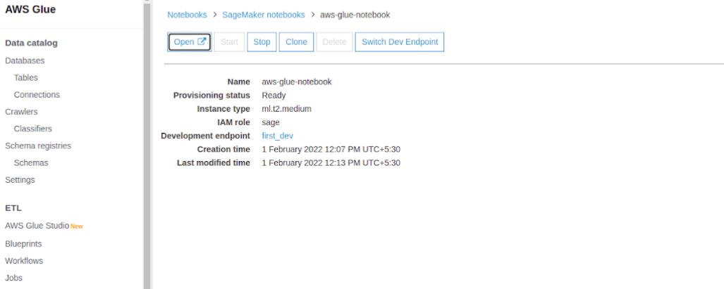

19. JSON Crawlers List:

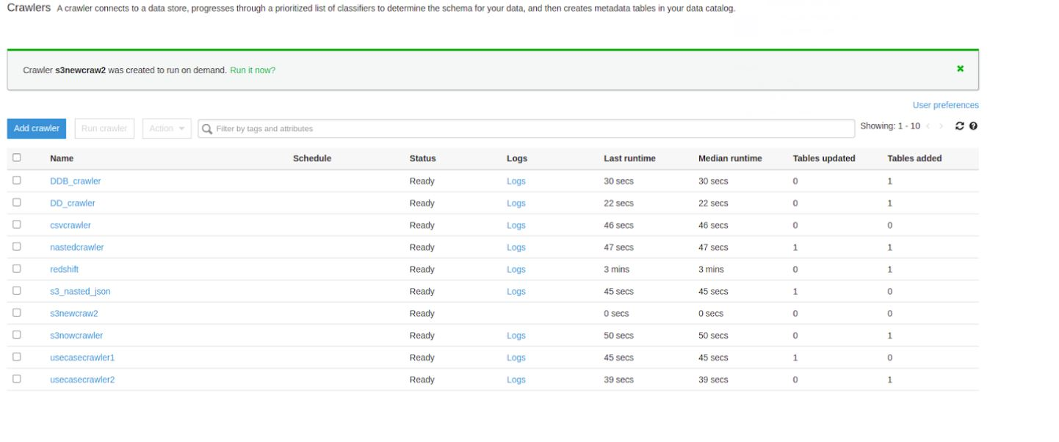

20. Crawler list for Nested JSON:

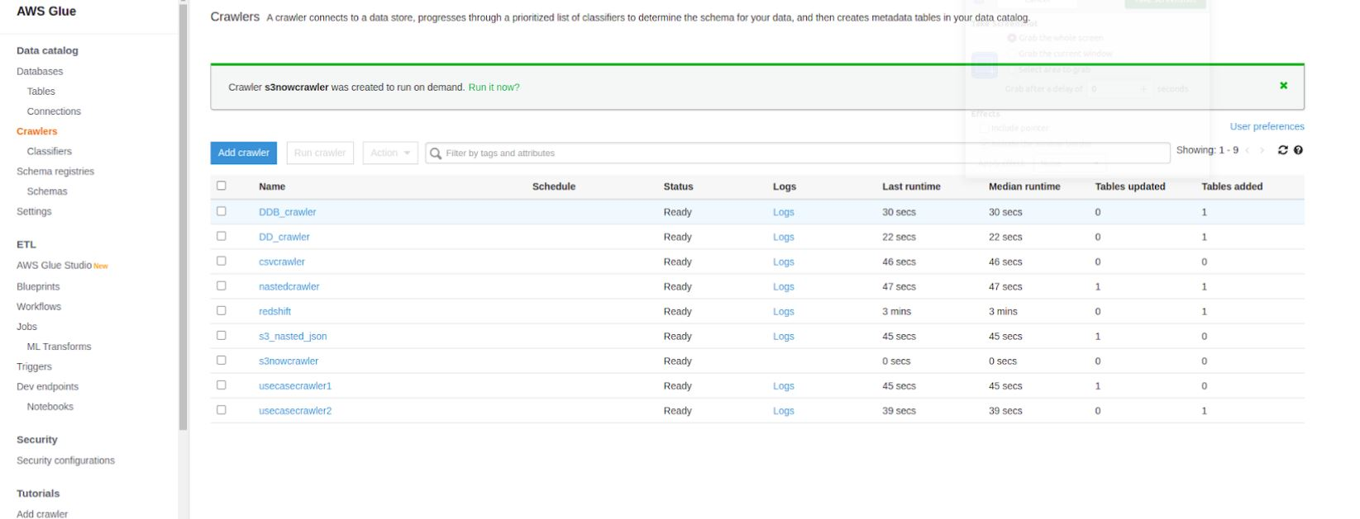

21. CDK Jupiter:

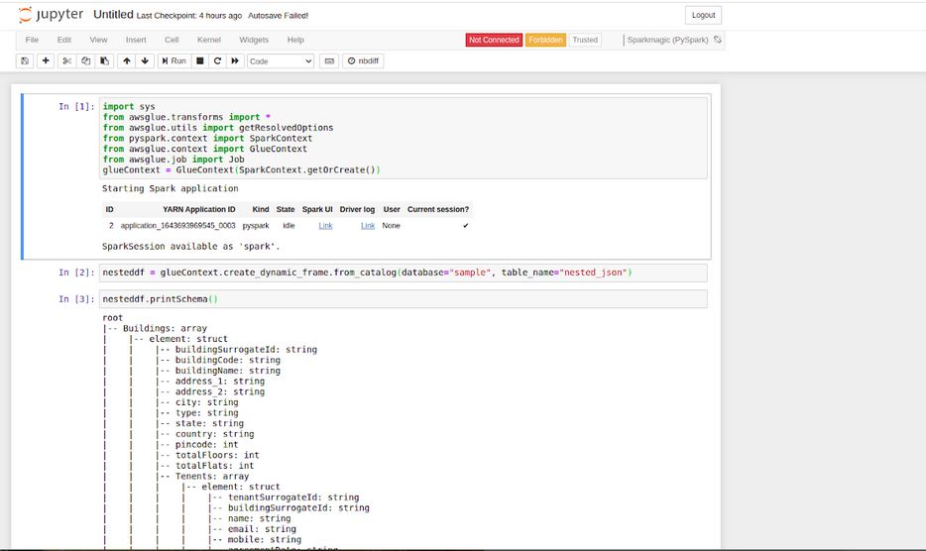

22. RDS Jobs:

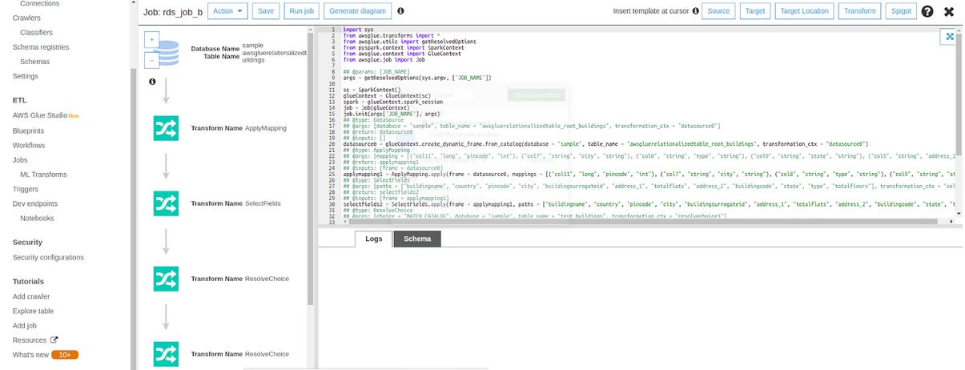

23. QuickSite Data Visualization Results:

